Interdisciplinarity  at the service of society:  Interpreting the evolution  of COVID-19 | 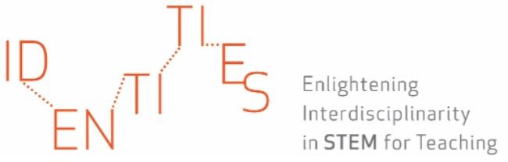  International 2021 Online Summer School
1st guide for interdisciplinary analysis on the news

Based on the news that has been assigned to you, you are now guided to reflect on the following aspects. To answer the questions, complete the table in Miro with all the relevant aspects.

- Which are the main questions that the research/academic/educational community has been studying regarding the evolution of COVID 19?

- Which STEM disciplines can you detect that have contributed to this discussion? How have these disciplines interacted?

- Which are the answers provided on the topic by the research/academic/educational community that the piece of news highlights (in case there are)?

- Which tools and disciplinary knowledge (concepts and/or methods) have contributed to give answers/solve/address these questions?

- Which specific terminology do you recognize in the text? Which terminology was already known by the non-expert public? Which terminology is new?

