NanoScience – NanoTechnology / NST

ID analyst: Worksheet 1

Activity 1a

In the Smart Houses activity we came across various representations of the water drop / surface interaction.

REPRESENTATION A

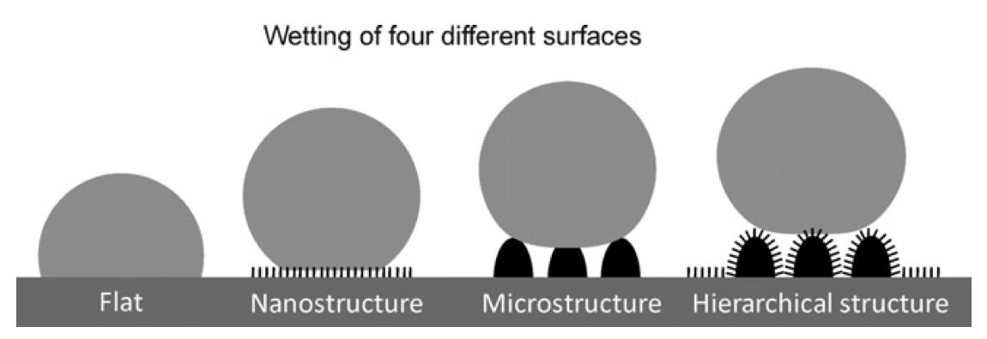
Reused from Frigione & Lettieri (2018)

REPRESENTATION B

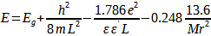

REPRESENTATION C

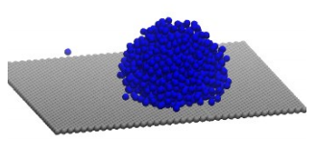
Reused from Yesudasan (2021)

REPRESENTATION D

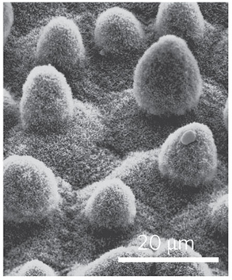
Reused from Bocquet & Lauga (2011)

1) Which STEM discipline/disciplines does each of the following representations refer to?

2) Which is the role of these representations in the NST field? Is there any differentiation in the use of such representations?

Activity 1b

In the Microscopes activity you produced a representation of a given surface. Using the same data set, we can produce several representations, like the following.

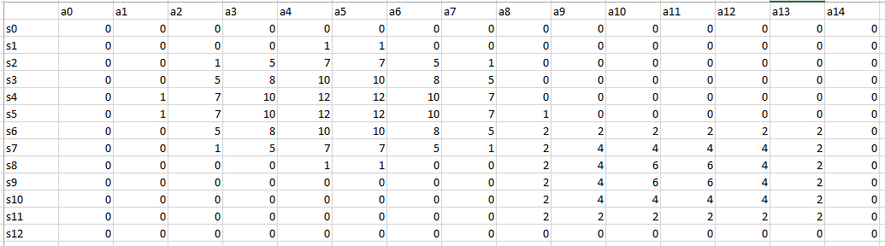

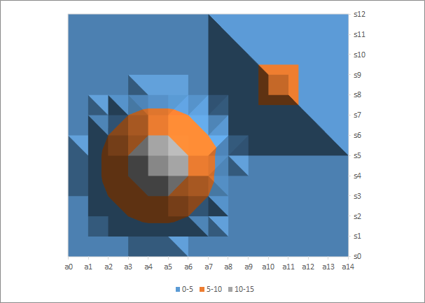
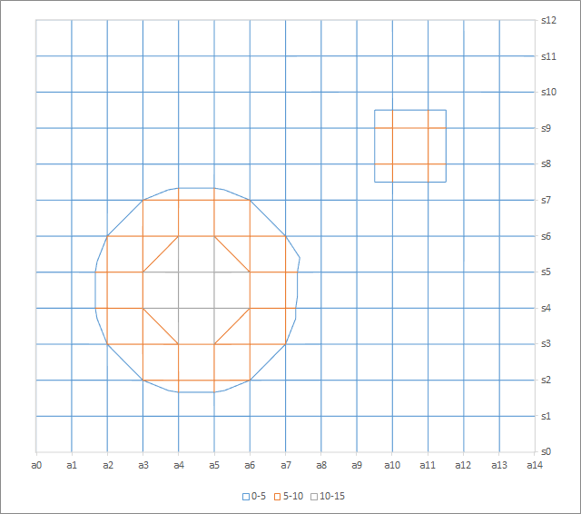
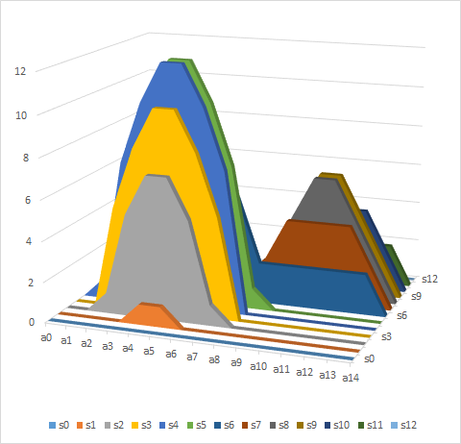
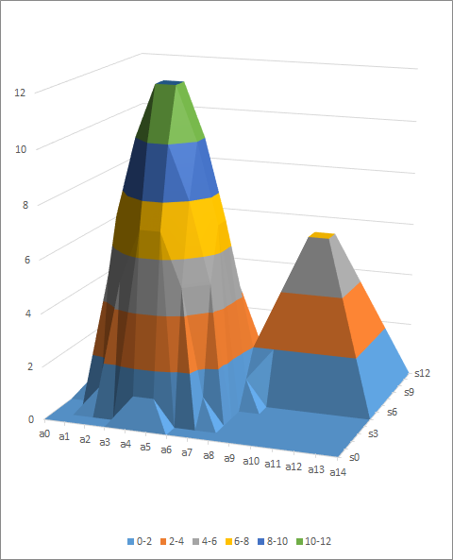

3) Where are the differences among the representations due to?

4) Is there a representation that describes the real surface in a more accurate way?

5) What is the role of Modelling/ Simulations in Research & Development of NST? Can you identify different modelling practices/ perspectives among S-T-E-M disciplines?

Activity 2

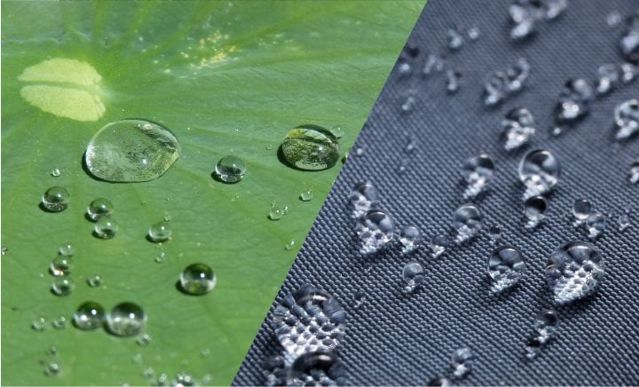
Reused by The Biomimicry Institute (2021)

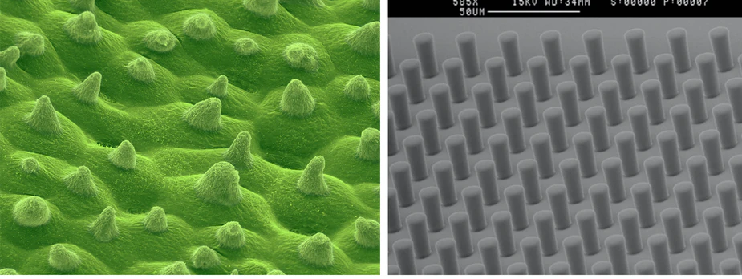
Reused by Science Photo Library (2022)

6) How do you think research evolved on studying & manufacturing such surfaces? How would you describe the process?

7) How does each S-T-E-M field contribute to the development of such superhydrophobic surfaces?

8) What is the role of Biomimetics in Research & Development of NST? Can you identify different practices/ perspectives on Biomimesis among S-T-E-M disciplines?

Activity 3a

Follow the link and view the presentation slides with the title “The history of microscopes evolution”:

https://identitiesproject.eu/wp-content/uploads/2022/11/Presentation_ID-analyst_Activity-3a_worksheet-1.pdf

9) Form a short commentary on the interplay between scientific progress (physics, biology, chemistry, maths etc), the instrumentation progress and society advancement.

Activity 3b

A team of researchers is working on the visualisation of a nanosurface using a STM. The following image depicts the process that the surface information is subjected to.
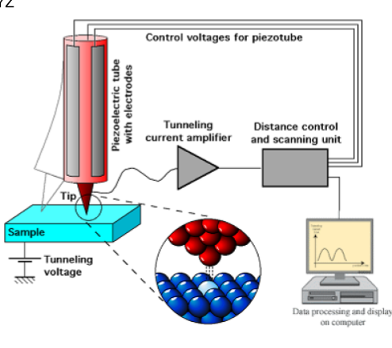
Reused from Schmid, M. (2005)
10) What kind of expertise should the above mentioned professionals have in order to complete this task?

11) What is the role of Instrumentation in Research & Development of NST? Can you identify interactions/ differences among S-T-E-M disciplines regarding instrumentation?

Activity 4a

Efficiency
12) Have you traced the terms “efficient/ efficiency” in the examples of smart houses and/or microscopes that you elaborated? What did it mean?

13) Irrespective of the context, how would you describe the term “efficiency” and when would you use it?

Context A
An initial appraisal of the engine thermal efficiency at full load capacity indicates a heat-to-power ratio of 1.56:1, representing a thermal efficiency of 39.1%, when calculated on the saturated lower calorific value of the fuel = 32.9 MJ/m3 (? 39.1 MJ/m3 dry gross saturated lower calorific value). When the engine is operating at part load, the gross thermal efficiency falls to approximately 28.9% at 22% load rating.
Al-Shemmeri (2011)

Context B
Further results reveal that the eight world regions contain the fastest growing countries, having the latest technology and the largest amount of foreign capital and managerial expertise to improve environmental efficiency by decreasing fossil fuel and increasing the consumption of renewable energy. Lower energy efficiency and environmental index score show that the fast economic growth and development cause heavy pressure on environmental protection and energy consumption, while higher energy efficiency and environmental index score show that even though fast economic growth and development exist, these countries are fighting against environmental degradation by adopting renewable energy.
Anser, et al. (2020)

14) Is the meaning of the term “efficiency” differentiated in the STEM disciplines?

15) Do you think that this different meaning is an obstacle regarding the interplay of STEM disciplines in the field of NST?

Activity 4c

Natural/ Artificial
16) Have you traced the terms “natural / artificial” in the examples of smart houses and/or microscopes that you elaborated? What did it mean?

17) Irrespectively of the context, how would you describe the terms “natural / artificial” and when would you use them?

Context A
In addition to providing an inexpensive source of vanillin—in higher purity than one could obtain from natural vanilla extract—this synthesis enables production of vanillin derivatives possessing desirable qualities, like increased flavor potency and thermal stability. For example adding one extra carbon atom to vanillin affords ethyl vanillin, which is 2–4 times more flavorful than vanillin itself
Kennedy (2015)

Context B

Researchers have been trying to create artificial cells for more than 20 years — piecing together biomolecules in just the right context to approximate different aspects of life. Although there are many such aspects, they generally fall into three categories: compartmentalization, or the separation of biomolecules in space; metabolism, the biochemistry that sustains life; and informational control, the storage and management of cellular instructions.
Powell (2018).

18) Is the meaning of the terms “natural / artificial” be differentiated in the STEM disciplines?

19) Do you think that this different meaning is an obstacle regarding the interplay of STEM disciplines in the field of NST?

20) Can you identify other a) concepts, b) methods/techniques, c) artefacts/tools, d) questions that bridge discontinuities in action/ interaction between different STEM disciplines?

21) Can you think of other linguistic terms that gain diverse meanings/interpretations between S-T-E-M disciplines in the context of NST?

References

Al-Shemmeri, T.-T. (2011). Thermodynamics, performance analysis and computational modelling of small and micro combined heat and power (CHP) systems. In Beith R. Small and Micro Combined Heat and Power (CHP) Systems: Advanced Design, performance, materials and applications, pp.42-69. Woodhead Publishing.
Anser, M. K., Iqbal, W., Ahmad, U. S., Fatima, A., & Chaudhry, I. S. (2020). Environmental efficiency and the role of energy innovation in emissions reduction. Environmental Science and Pollution Research, 27(23), 29451-29463.
Bocquet, L., & Lauga, E. (2011). A smooth future?. Nature materials, 10(5), 334-337.
Biomimicry Institute (2021). https://asknature.org/resource/keeping-it-clean/
Frigione, M., & Lettieri, M. (2018). Novel attribute of organic–inorganic hybrid coatings for protection and preservation of materials (stone and wood) belonging to cultural heritage. Coatings, 8(9), 319.
Kennedy, C. R. (2015). The flavor rundown: Natural vs. Artificial flavors. Harvard University: Science in the News, 21. https://sitn.hms.harvard.edu/flash/2015/the-flavor-rundown-natural-vs-artificial-flavors/
Michael Schmid, M. (2005). Schematic diagram illustrating the operation of a scanning tunneling microscope. https://commons.wikimedia.org/wiki/%20w/index.php?curid=180388
Powell, K. (2018, November 7). How biologists are creating life-like cells from scratch. Nature. https://www.nature.com/articles/d41586-018-07289-x
Science Photo Library (2022). https://www.sciencephoto.com/media/462601/view/lotus-leaf-surface-sem
Yesudasan, S. (2021). Achilles: A Tool for Contact Angle Estimation from Molecular Dynamics Simulations. Preprints, 148(1).

