

The three images below are emblematic of this historical episode: the fall of the Aristotelian paradigm and the birth of modern physics.

Link to the jam board for the group activity: https://jamboard.google.com/d/1l5voQCl2eju0bF_34-_2v9yn5F87gdywU2SGHEgbwPg/edit?usp=sharing

By observing the images and reading the passages, answer the following questions:
- What kind of knowledge do the three images embody?
- What epistemological elements distinguish figure b and c from figure a? To what extent do they characterize physics as a discipline?
- How would you describe the vertical orange bars? In other words, what concepts/elements/aspects activated the epistemological changes that moved knowledge from medieval to modern science?
- What role of mathematics in physics emerges from this case study?

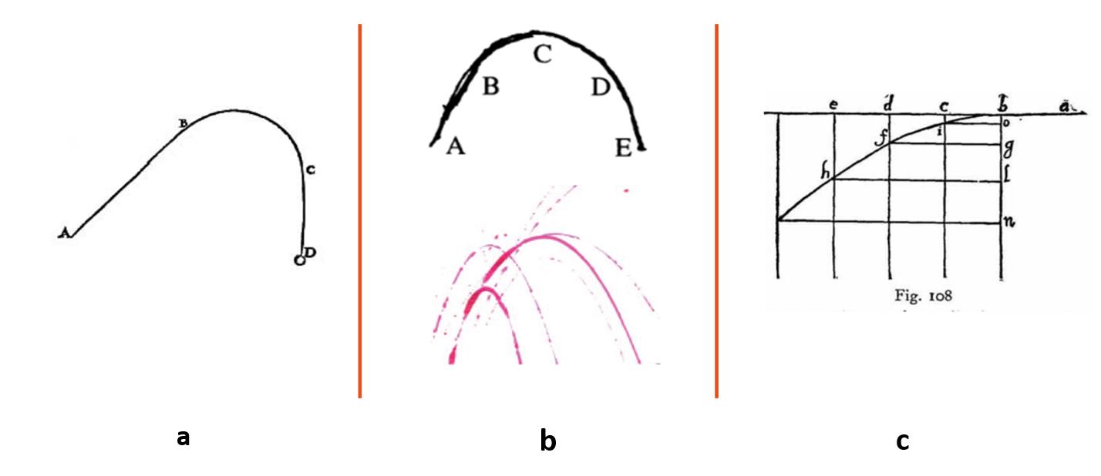

Text #1: From Renn, J., Damerow, P., Rieger, S., & Giulini, D. (2001). Hunting the white elephant: When and how did Galileo discover the law of fall?. Science in Context, 14(s1), 29.

According to Tartaglia's theory, the trajectory of a projectile consists of three parts. It begins with a straight part that is followed by a section of a circle and then ending in a straight vertical line (see figure [on the right]). This form of the trajectory also corresponds to Tartaglia's adaptation of the Aristotelian dynamics to projectile motion in the case of artillery […]. […] The first part of the trajectory was conceived by Tartaglia as reflecting the initially dominant role of the violent motion, whereas the last straight part is in accord with the eventual dominance of the projectile's weight over the violent motion and the tendency to reach the center of the earth. […] He claimed instead the curved part to be exclusively due to violent motion as is the first straight part of the trajectory.

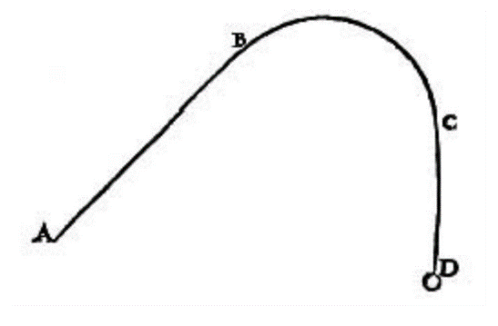
Fig. 1: Tartaglia’s representation of the projectile motion in his Nova Scientia (1537).

Text #2: From Guidobaldo notebook (1592)
If one throws a ball with a catapult or with artillery or by hand or by some other instrument above the horizontal line, it will take the same path in falling as in rising, and the shape is that which, when inverted under the horizon, a rope makes which is not pulled, both being composed of the natural and the forced, and it is a line which in appearance is similar to a parabola and hyperbola. And this can be seen better with a chain than with a rope, since [in the case of] the rope abc, when ac are close to each other, the part b does not approach as it should because the rope remains hard in itself, while a chain or a little chain does not behave in this way. The experiment of this movement can be made by taking a ball colored with ink, and throwing it over a plane of a table which is almost perpendicular to the horizontal.
Although the ball bounces along, yet it makes points as it goes, from which one can clearly see that as it rises so it descends, and it is reasonable this way, since the violence it has acquired in its ascent operates so that in falling it overcomes, in the same way, the natural movement in coming down so that the violence that overcame [the path] from b to c, conserving itself, operates so that from c to d [the path] is equal to cb, and the violence which is gradually lessening when descending operates so that from d to e [the path] is equal to ba, since there is no reason from c towards de that shows that the violence is lost at all, which, although it lessens continually towards e, yet there remains a sufficient amount of it, which is the cause that the weight never travels in a straight line towards e.
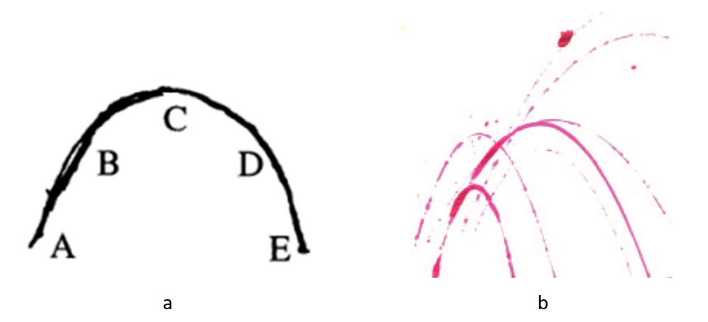
Fig. 2: Representation of the motion of the projectiles, from Guidobaldo's notes; b. Reproduction of Guidobaldo's experiment (Cerreta, 2019)

Text #3: From Dialogues on Two Sciences, Galileo
“Theorem I, Proposition I
A projectile which is carried by a uniform horizontal motion compounded with a naturally accelerated vertical motion describes a path which is a semi-parabola. […]
Let us imagine an elevated horizontal line or plane ab along which a body moves with uniform speed from a to b. Suppose this plane to end abruptly at b; then at this point the body will, on account of its weight, acquire also a natural motion downwards along the perpendicular bn. Draw the line be along the plane ba to represent the flow, or measure, of time; divide this line into a number of segments, bc, cd, de, representing equal intervals of time; from the points b, c, d, e, let fall lines which are parallel to the perpendicular bn. On the first of these lay off any distance ci, on the second a distance four times as long, df; on the third, one nine times as long, eh; and so on, in proportion to the squares of cb, db, eb, or, we may say, in the squared ratio of these same lines. Accordingly we see that while the body moves from b to c with uniform speed, it also falls perpendicularly through the distance ci, and at the end of the time-interval bc finds itself at the point i. In like manner at the end of the time interval bd, which is the double of bc, the vertical fall will be four times the first distance ci; for it has been shown in a previous discussion that the distance traversed by a freely falling body varies as the square of the time; in like manner the space eh traversed during the time be will be nine times ci; thus it is evident that the distances eh, df, ci will be to one another as the squares of the lines be, bd, bc. Now from the points i, f, h draw the straight lines io, fg, hl parallel to be; these lines hl, fg, io are equal to eb, db and cb, respectively; so also are the lines bo, bg, bl respectively equal to ci, df, and eh. The square of hl is to that of fg as the line lb is to bg; and the square of fg is to that of io as gb is to bo; therefore the points i, f, h, lie on one and the same parabola. In like manner it may be shown that, if we take equal time-intervals of any size whatever, and if we imagine the particle to be carried by a similar compound motion, the positions of this particle, at the ends of these time-intervals, will lie on one and the same parabola.”


