Group:
Group members:

Guide to the 'cylinder' experiment
The guide is divided into three parts: Reflect, Predict, Interpret.
Part 1. Reflecting
Dear students,
Going over the topics seen in the last lesson, we ask you to think again about the meaning of some common language words also used in the language of physics: opaque, glossy, transparent.
Try to give a 'physical' definition of these words and give examples of real situations and/or objects to which they can be related.

Exercise 1.
An opaque object A (e.g. a block of wood or a stone) and a transparent object B, having the same heat capacity and the same initial temperature of , are exposed to sunlight for a time t. The temperature e of the two objects at the end of the exposure time will be:
a.
b.
c.
d. Don't know
Justify your answer.

Exercise 2.
Three objects (e.g. three aluminium cylinders with the same heat capacity) are exposed to the sun for a long time. The objects have the following characteristics:
SUBJECT 1🡪 matt black
OBJECT 2🡪 matt white
SUBJECT 3🡪 transparent
In your opinion, will each object reach an equilibrium temperature?
Object | Yes | No | I don't know
BLACK and MATT
WHITE and MATT
TRANSPARENT

Justify your answer.

Exercise No. 3.
An opaque object is exposed to sunlight for a time t and then (after being returned to the same initial T) is exposed to the light of an incandescent bulb for the same time. It indicates what the temperature of the object will be at the end of the exposure time in the two cases (= temperature in sunlight, = temperature in lamp light):
a.
b.
c.
d. Don't know
Justify your answer.

Exercise No. 4.
Two objects, one opaque white (A) and one polished aluminium (B), having the same heat capacity and initial temperature are exposed for the same time t in different situations:
Situation 1. Exposure to sunlight
Situation 2. Exposure to bulb light
The temperature e of the two objects at the end of the exposure time will be:
Situation 1.  Exposure to sunlight | Situation 2.  Light bulb exposure
a.  b.  c.  d. Don't know | a.  b.  c.  d. Don't know

Justify your answers and try to draw a graph of the temperature trend as a function of time of the objects in both situations.
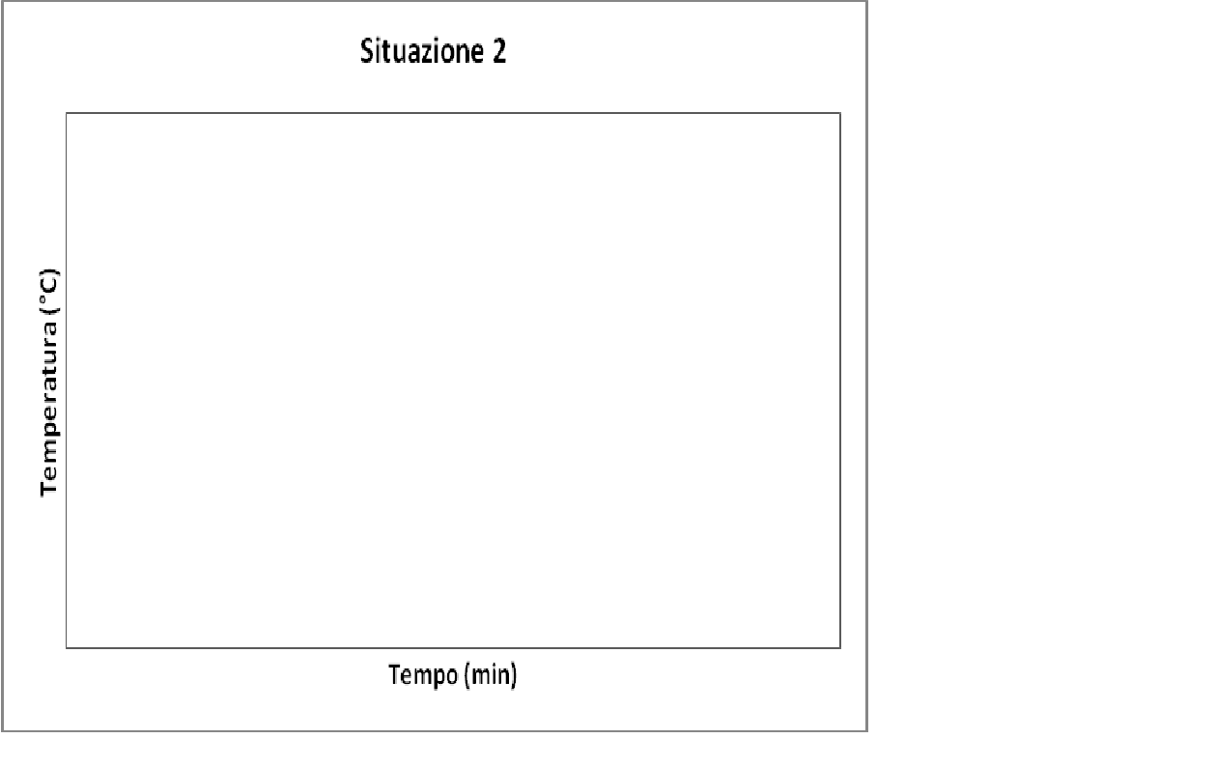
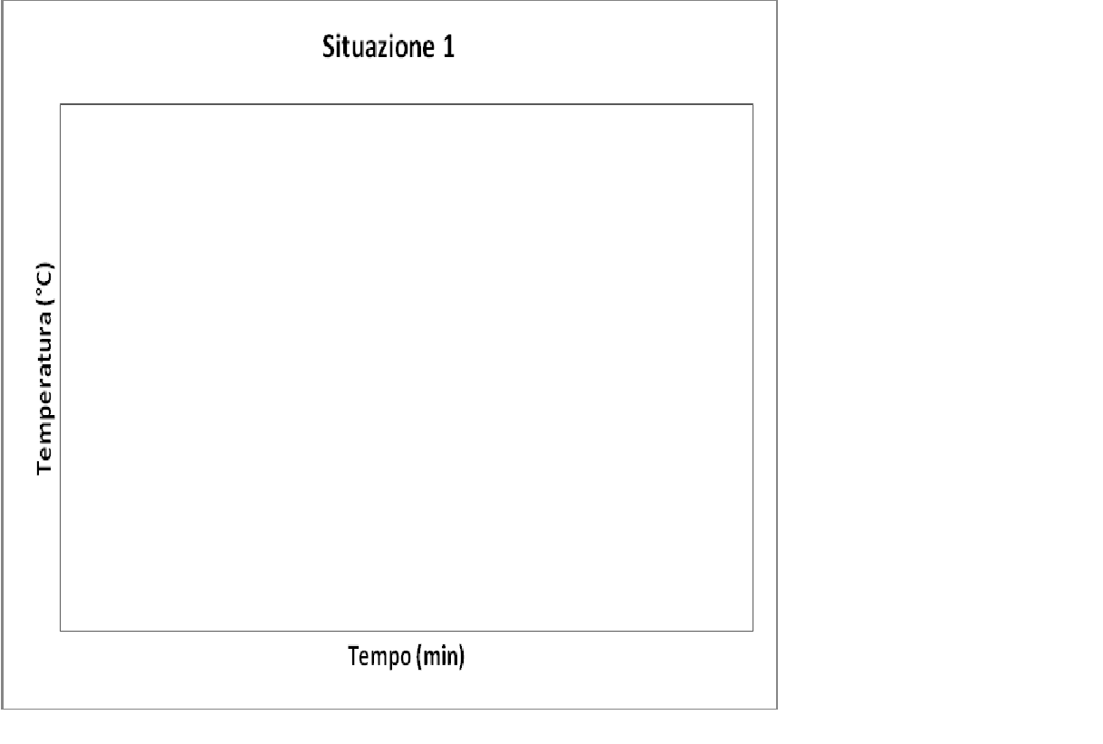

Part 2. Provide

Before the experiment is completed, on the basis of what you have seen in the previous lesson, try to draw, in the same graph, the temperature trend (T) as a function of time (t) for each of the cylinders you have and highlight what you consider important.

Thinking back to the physics concepts introduced in the previous lesson, how would you explain the trend in the graph you predicted?

Part 3. Interpreting
How does the graph obtained differ from your prediction?

Box-Ground Experiments' Guide
The guide is divided into two parts: Reflect, Predict & Interpret.
Part 1. Reflect [NO DRAWING IS NECESSARY BUT REASONING IS SUFFICIENT].
Dear students,
Thinking back to the topics seen in the last lesson, we ask you to focus your attention on the atmosphere and reflect, first, on its behaviour in the radiation-atmosphere interaction process (assuming there is no Earth) and, then, on its role in the radiation-atmosphere-Earth interaction).
So, specifically, we ask you to try to:
- draw a 'your model' of radiation-atmosphere interaction (under the constraint of the assumption that the atmosphere can be modelled as a homogeneous and uniform body) as the absorbance of the atmosphere varies (0≤ to≤ 1), also giving an explanation of your proposed model;
- draw a 'your model' of radiation-atmosphere-Earth interaction (under the assumptions of the atmosphere as a homogeneous and uniform body, and the Earth as a black body) as the absorbance of the atmosphere varies (0≤ to≤ 1), also giving an explanation of your proposed model.

1st Hypothesis: RADIATION-ATMOSPHERE

Atmosphere with a=0

Atmosphere with 0<a<1 (e.g. 0.5, 0.7, etc.)

Atmosphere with a=1

2nd Hypothesis: RADIATION-ATMOSPHERE-TERRA

Atmosphere with a=0

Atmosphere with 0<a<1 (e.g. 0.5, 0.7, etc.)

Atmosphere with a=1

Part 2. Predicting & Interpreting

Before the experiment is complete, try to draw a hypothesis of the graph you might observe by exposing the box (WITHOUT lid) to the light of the light bulb and highlight the things you consider important.

Now try to draw a hypothesis of the graph you might observe by exposing the box to the light of the light bulb (WITH a lid) and highlight the things you consider important.

Finally, try to draw a hypothesis of the graph you might observe by exposing the box to the light of the bulb (first without the lid and then adding the lid at some point) and highlight the things you consider important.

Try to motivate your graphs.

[INTERPRET] Did the graphs observed during the experiment differ from your predictions? If yes, in what way?

