The growth of trees
(Sonia Yvain-Prebiski, Simon Modeste; 2020)

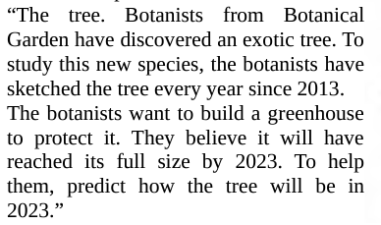

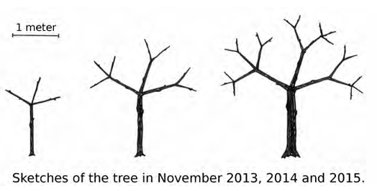

- Ask questions that you need to think of a mathematical treatment of such a prediction.

……………………………………………………………………………………………………………
……………………………………………………………………………………………………………
……………………………………………………………………………………………………………
……………………………………………………………………………………………………………
……………………………………………………………………………………………………………
……………………………………………………………………………………………………………
……………………………………………………………………………………………………………
……………………………………………………………………………………………………………
……………………………………………………………………………………………………………
……………………………………………………………………………………………………………
……………………………………………………………………………………………………………
……………………………………………………………………………………………………………

- Exchange your questions and try to answer the questions of the other group.

……………………………………………………………………………………………………………
……………………………………………………………………………………………………………
……………………………………………………………………………………………………………
……………………………………………………………………………………………………………
……………………………………………………………………………………………………………
……………………………………………………………………………………………………………
……………………………………………………………………………………………………………
……………………………………………………………………………………………………………
……………………………………………………………………………………………………………
……………………………………………………………………………………………………………
……………………………………………………………………………………………………………

- Now share your questions and answers and discuss with your mates about the process you experienced in a mathematical modelling activity in order to deal with the mathematical treatment of the problem and about the choices that have been made explicitly.
……………………………………………………………………………………………………………
……………………………………………………………………………………………………………
……………………………………………………………………………………………………………
……………………………………………………………………………………………………………
……………………………………………………………………………………………………………
……………………………………………………………………………………………………………
……………………………………………………………………………………………………………
……………………………………………………………………………………………………………
……………………………………………………………………………………………………………
……………………………………………………………………………………………………………
……………………………………………………………………………………………………………
……………………………………………………………………………………………………………
……………………………………………………………………………………………………………

